Star topology is most suited for LAN because:

1. Eliminates searching entire buildings for breaks.
2. Typically utilizes inexpensive UTP cabling.
3. Centralizes the required electronics for troubleshooting.
4. Wiring/cross-connect changes only require visit to the closet or endpoint.
5. Can extend range with a star of stars.

However, star topology alone does not serve the purpose needed here because there are two LANs. So, I have used a hybrid of star and bus topology with the end nodes of the bus serving as the hub in the star topology.

The following is how the structure looks-

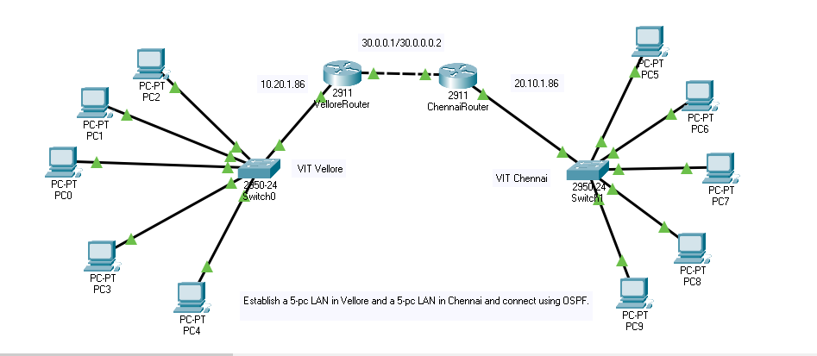

The PCs communicate via the switch, which either adds or removes a computer from an active communication depending upon the information contained in the header files of the packets received.

The communication between the LANs is coordinated through the routers that maintain the routing table, IP list and in the current OSPF routing, are grouped into areas. Our model uses only one backbone area, area 0. The main benefits of using *areas* in an OSPF network are:

* Routing tables on the routers are reduced.
* Routing updates are reduced.

**EXPERIMENT:**

1. Set-up the configuration
2. Set-up the ips of all possible ports

VIT Vellore has IP addresses of the type 10.10.1.8x where x is 1 to 5

VIT Chennai has IP addresses of the type 20.10.1.8x where x is 1 to 5

The router VelloreRouter has IP address 10.10.1.86 on the port connected to the switch and 30.0.0.1 on the port connected to the ChennaiRouter.

The ChennaiRouter has IP 20.10.1.86 on the port connected to the switch and 30.0.0.2 in the port connected to the VelloreRouter.

1. Set-up default gateways in all PCs.
2. Set-up ospf configuration in Vellore Router or R1 as area 0

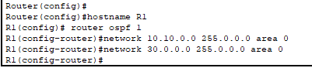

1. Set-up ospf configuration in Chennai Router or R2 as area 0.

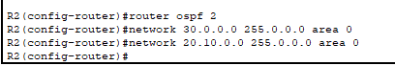

1. Check ospf neighbours and also if R1 has learnt of the route

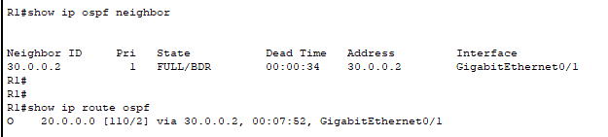

Similarly, for R2

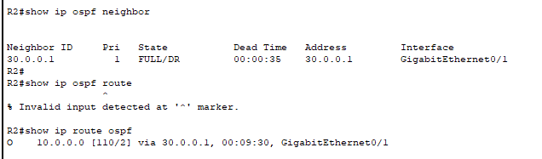

This verifies our ospf network has been established.

Let me verify further with R1

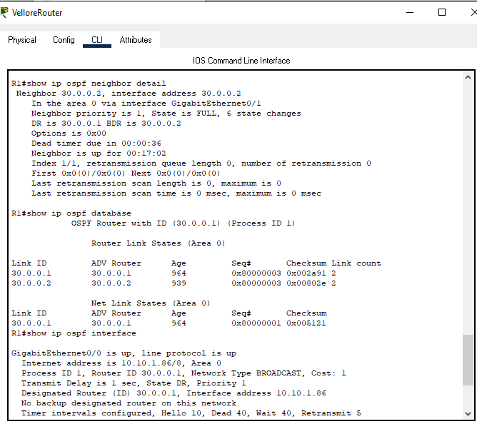

We can safely assume that the OSPF protocol has been established.

1. Finally, to check connectivity, ping systems

Two PCs in the Vellore LAN network

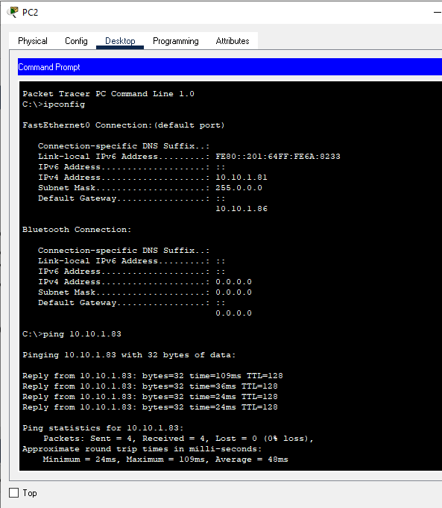

Two PCs in the Chennai LAN network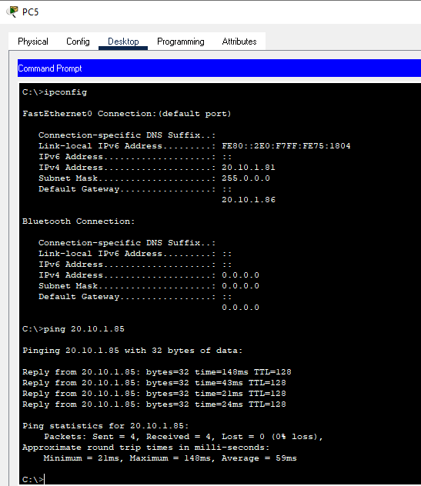

Two PCs – one in Vellore, one in Chennai between systems not considered in the previous pings